**Synopsis**

**On**

**“AgriNews”**



**Submitted By: Guide By:**

Nigam Patel (06-0221-2016) Prof. R.S Parmar

**Signature:**

__________________________

Table of Contents

1) Title**:** 3

2) Introduction: 3

3) Objectives: 3

4) Platform/Hardware and Software: 3

a) Platform: Apache Tomcat Server, Eclipse IDE. 3

b) Software/Language: 3

5) Description 4

a) Interfaces 4

b) Modules 4

6) Zero Level Flow Diagram 5

7) ER Diagram 5

8) Data Dictionary 6

a) NewsHeadline 6

b) NewsDescription 6

c) User 7

d) Post 7

e) Like 7

f) Comment 8

9) Bibliography 8

# Title**:**

* AgriNews

# Introduction:

Traditionally, agricultural information exchange has been dominated by industrial media such as newspapers, television and magazines. But now the power of the 21st century is literally in our hands. AgriNews are web based tools of communication that allow users to personally interact with others individually or in groups for the purposes of exchanging information, sharing thoughts and opinions, influencing and facilitating decision-making by creating, storing, retrieving and exchanging information in any form (text, pictures, video, etc.,) by anyone in the virtual world.

# Objectives:

* Our project provides most recently agriculture news related to current time and place.
* Website allow users to personally interact with others individually or in groups for the purposes of exchanging information, sharing thoughts and opinions by post, comment and like.
* Provide weather related data from various places in the world so farmer can know what operation is suitable for the crop.
* And user can see agriculture commodities prices of various city’s APMC daily.

# Platform/Hardware and Software:

## **Platform**: Apache Tomcat Server, Eclipse IDE.

## **Software/Language:**

* Language**:** JAVA (Spring framework).
* Operating System:Windows 8.1.
* Back End: MySQL Server.

# Description

# Interfaces

* Admin:
* In this module admin can manage news and view its user activity
* User:
* User allows us to see all agriculture news and another user’s post. It can be adding your post and manage it.
* If user wish to comment or like to some post so it can.

# Modules

1. **Login/Registration Module:**

* This module is mandatory for this user that can add your own post and not for this user that only see the news. In this module user give your credential and login to the website.

1. **News Module:**

* This module provides an agriculture news from varies place of country time by time.

1. **Post Module:**

* Post module is only for registered user so without registration user can’t use post module so whenever he wants to upload a post on website so first login to the website after that can be done. In this module user add your post (Image, Video, Text etc.) and manage it.

# Zero Level Flow Diagram

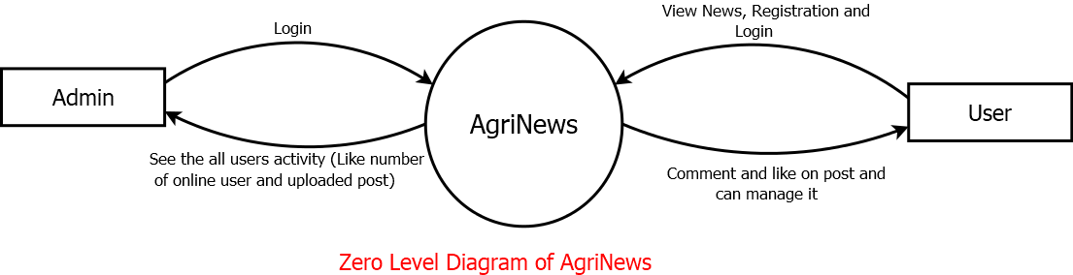

# ER Diagram

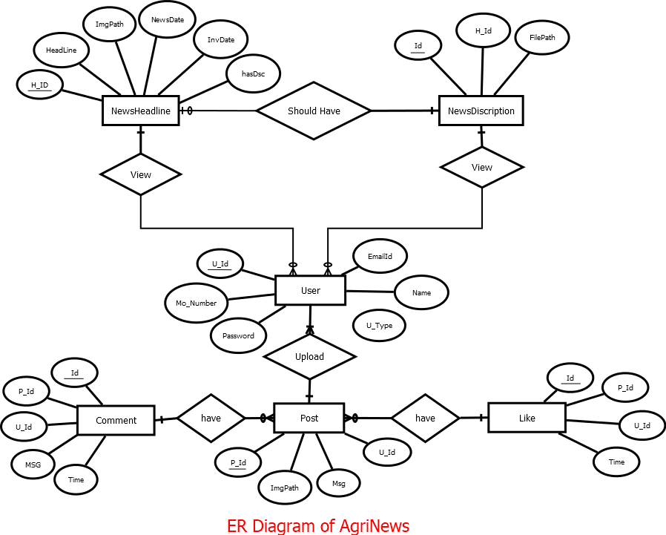

# Data Dictionary

## NewsHeadline

|  |  |  |  |  |  |
| --- | --- | --- | --- | --- | --- |
| **Sr no** | **Field Name** | **Data Type** | **Size** | **Constrain** | **Description** |
| 1 | H_No | Int | 11 | Primary Key | Headline Id |
| 2 | Headline | Varchar | 30 | Not Null | Headline of News |
| 3 | HasDiscription | Int | 11 | Not Null | Flag of Discription |
| 4 | Region | Varchar | 30 | Not Null | Category of News |
| 5 | ImagePath | Varchar | 50 | Not Null | Path of Image |
| 6 | NewsDate | Date | - | Not Null | Date of News |
| 7 | InvDate | Date | - | Not Null | Date of Entry |

## NewsDescription

|  |  |  |  |  |  |
| --- | --- | --- | --- | --- | --- |
| **Sr No** | **Field Name** | **Data Type** | **Size** | **Constrain** | **Description** |
| 1 | D_Id | Int | 11 | Primary Key | Description id |
| 2 | Description | Varchar | 30 | Not Null | Description of News |
| 3 | H_Id | Int | 11 | Foreign Key | Headline Id of News |

## User

|  |  |  |  |  |  |
| --- | --- | --- | --- | --- | --- |
| **Sr No** | **Field Name** | **Data Type** | **Size** | **Constrain** | **Description** |
| 1 | U_Id | Int | 11 | Primary Key | Id of User |
| 2 | Name | Varchar | 30 | Not Null | Name of User |
| 3 | Email_Id | Varchar | 50 | Not Null | Email Id of User |
| 4 | Type | Varchar | 20 | Not Null | User Type(Admin | User) |
| 5 | Password | Varchar | 30 | Not Null | Password of User |
| 6 | Mo_No | Varchar | 10 | Not Null | Mobile Number of User |

## Post

# 

|  |  |  |  |  |  |
| --- | --- | --- | --- | --- | --- |
| **Sr No** | **Field Name** | **Data Type** | **Size** | **Constrain** | **Description** |
| 1 | P_Id | Int | 11 | Primary Key | Id of Post |
| 2 | ImagePath | Varchar | 30 | Not Null | Path of Image |
| 3 | Description | Varchar | 50 | Not Null | Email Id of User |
| 4 | U_Id | int | 11 | Foreign Key | Id of user |

## Like

# 

|  |  |  |  |  |  |
| --- | --- | --- | --- | --- | --- |
| **Sr No** | **Field Name** | **Data Type** | **Size** | **Constrain** | **Description** |
| 1 | L_Id | Int | 11 | Primary Key | Id of Like |
| 2 | P_Id | Int | 11 | Foreign Key | Id of Post |
| 3 | Flag | Varchar | 10 | Not Null | Like and dislike flag |
| 4 | U_Id | int | 11 | Foreign Key | Id of User |

## Comment

|  |  |  |  |  |  |
| --- | --- | --- | --- | --- | --- |
| **Sr No** | **Field Name** | **Data Type** | **Size** | **Constrain** | **Description** |
| 1 | L_Id | Int | 11 | Primary Key | Id of Like |
| 2 | P_Id | Int | 11 | Foreign Key | Id of Post |
| 3 | Message | Varchar | 100 | Not Null | Message of Comment |
| 4 | Flag | Varchar | 10 | Not Null | Like and dislike flag |
| 5 | U_Id | int | 11 | Foreign Key | Id of User |

# 

# Bibliography

* Referring online manual from
* https://economictimes.indiatimes.com/news/economy/agriculture
* https://krishijagran.com/
* https://www.thehindubusinessline.com/economy/agri-business/